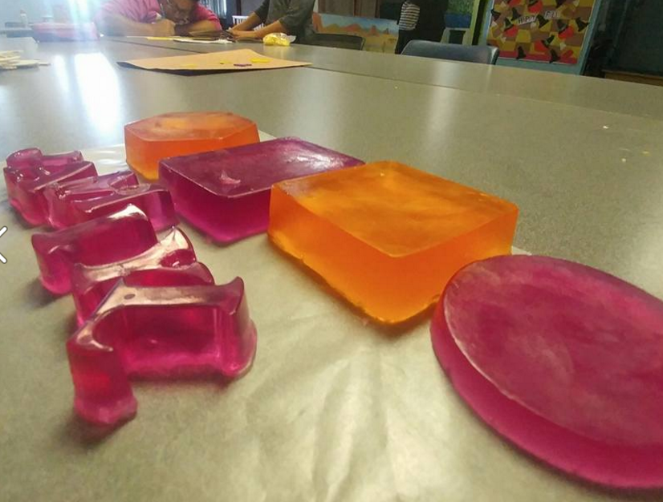  D.I.Y. Soap Bars made by Project Beacon Participants.  Thank You!  With giant thanks to Community Foundation of SECT & Bodenwein for grant funding, The Light House and Creative Potential are thrilled to announce a new collaborative respite for families with children with special needs, Project Beacon. | Contact Us  Phone: 860-326-4528  Email: tjarrett@creatiepotentialllc.com  Project Beacon:  https://www.facebook.com/projectbeacon06340/  Creative Potential LLC:  http://www.creativepotentialllc.com/  The Light House:  http://lhcampus.com/  Project Beacon  46 Plaza Ct.  Groton CT, 06320 | Project Beacon  - Almost Free Respite
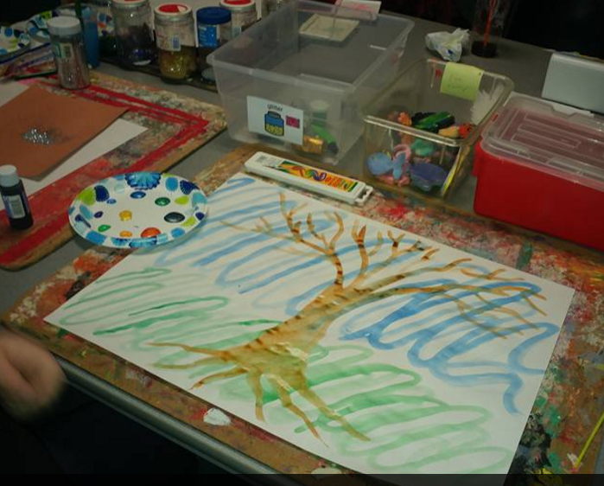  Creativity is contagious, pass it on.  -Albert Einstein  Project Beacon Schedule 2017  10:00 AM- 2:00 PM  March 11th 25th  April 8th 22nd  May 6th 20th  June 3rd 17th  July 1st 15th 29th  August 12th 26th  September 9th 23rd  October 7th 21st  November 4th 18th  December 2nd 16th  All dates and times are subject to cancelation or change. Families will be notified in the event of a cancelation. | Project Beacon Giving special needs parents a much-deserved break, when help from natural resources is not available.  Who Qualifies?  - Family with children between the ages 7 & 17 with special needs who is able to remain safe in a 5:1 play environment for 2-6hrs at a time  - Parents/Guardians with reliable transportation for pick up and drop off.  - Children who have independent bathroom skills.  - Family is able to provide lunch and/or snack for child to bring  - Child is communicative and able to process experience verbally or with technology with staff  - Children who do not require medication during the time of program or parent/ guardian is willing to administer meds during program. | 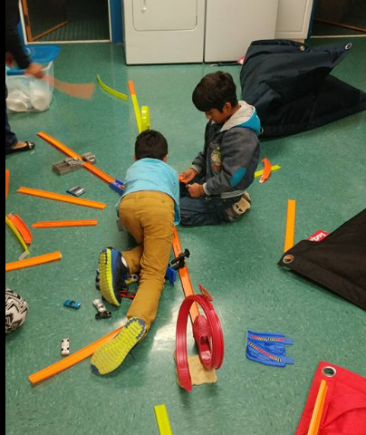  Playing with cars and tracks at Project Beacon. “Let’s build a highway!”  Towns invited to participate:  Children residing in Groton, New London, Montville, East Lyme, North Stonington, Stonington, Waterford, Old Lyme, Ledyard, or Lyme (grant is limited to these towns) *  *If your family does not reside in the 11 towns mentioned, residents of those 11 towns will be the top priority in filling slots. If there are slots available, the fee will be $10/hr. (as grant funds that allow sliding scale fees only cover those towns).

